- SCOPE:
  - This product specification document will constitute the basis of an important part of the design output based on the intention of the product and the product application.
  - As a general product specification, this specification include the general specification requirement and relative key technical requirement and standards of the portable mini plastic kegs, spear and inner bag assemblies, portable dispensing system; this specification document exclude the detail specification of specific components, which belongs to the detail control of internal process and/or incoming quality control, those specification please refer to the detail specification of components and/or components drawings.
  - Relevant international regulations related to product application and/or manufacturing, such as the relevant elements of ISO9000, and international regulations related to food contact, will form part of this product specification.

- DEFINITIONS AND ABBREVIATIONS
  - AQL : "Acceptable Quality Level", this is the maximum percentage of defect units in a lot, while the lot is still acceptable to the client. An AQL value should be considered for sampling purposes only and not as an acceptable process average
  - Lot : Quantity of goods, considered as a unity, for sampling purposes
  - Mil. St.: Military Standard
  - F.D.A.: Food and Drug Administration
  - ISO: International Standard Organization

- DOCUMENTS RELATED TO THE TECHNICAL SPECIFICATIONS
  - European Directives for Packaging materials(other countries/regions refer to the relevant directives, in principle, according to the strictest directives)
- Global Directive (materials and articles intent to contact with food) Regulation (EC) No 1935/2004
- Special directives (plastic materials and articles contact with food) Regulation (EU) No 10/2011
- Special directives (metal and alloy intent to contact with food) Resolution CM/Res (2013) 9
- Special directives (good manufacturing method …) Regulation (EC) No 2023/2006
- Special directives (food hygiene) Regulation (EC) No 852/2004

  - 85/374/EEC: Council Directive of 25 July 1985 on the approximation of the laws, regulations and administrative provisions of the Member States concerning liability for defective products。

  - Commission Directive 80/766/EEC of 8 July 1980 laying down the Community method of analysis for the official control of the vinyl chloride monomer level in materials and articles which are intended to come into contact with foodstuffs

  - Commission Directive 81/432/EEC of 29 April 1981 laying down the Community method of analysis for the official control of vinyl chloride released by materials and articles into foodstuffs

  - Federal Food, Drug and Cosmetic Act
- FDA CFR 21.175.300

  - ISO 2859 (Mil. St.-105D): Sampling procedures and tables for inspection by attributes。

- GENERAL CONDITIONS:
  - The portable dispensing tool consists of the compressed air pump assembly, the tapping/dispensing assembly.

  - The compressed air pump system combining an electrical pump and manual pump together, which acts as a pressure medium, to provide compressed air to be filled into the space between the inner beer bag and the keg body, to squeeze the inner beer bag to push out the beer and/or beverages, etc., for tapping/dispensing of the filled beer and/or beverages, etc. in the inner beer bag.

  - The dispensing/tapping system consists of a connection base for connecting the portable dispensing tool with the spear housing on the portable mini plastic keg, an elbow to form the tunnel for beer and/or beverages dispensing, and a tapping system to push/pull the elbow to open and close the valve in the spear of portable mini plastic kegs.

  - As high barrier performance of inner beer bag to both O2 and CO2, the compressed air from the pump system only goes into the space between the inner beer bag and the keg body, never goes into the inner bag to contact the beer and/or beverages filled into the inner bag, to ensure the filled beer and/or beverages in the inner beer bag never contaminated by the pressure medium, to make sure the beer and/or beverages in the opened portable mini plastic kegs can be still kept for at least one month.

  - The tapping system push the elbow through a lever system to open the beer valve in the spear mounted on the portable mini plastic keg, for beer and/or beverages dispensing; and pulling up the elbow through the same lever system to close the beer valve in the spear, thus to form a nonreturn valve in the beer and/or beverage dispensing tunnel, to prevent any beer and/or beverage in the tunnel to go back into the inner bag to contaminate the beer and/or beverages inside.

  - The portable dispensing tool assembly must in all respects be suitable to provide specified volume of compressed air at the specified pressure, to squeeze the inner bag and to completely empty the beer and/or beverages filled in the inner bag.

  - The dispensing/tapping system of the portable dispensing tool need to be adjustable, to adapt the dispensing performance, especially for different type of draft beer filled in the portable mini plastic kegs, to adapt the foam level of draft beer in glass during dispensing, a 2 to 3 step of foam control/adjustment system consist of part of the dispensing system.

  - All materials and additives for portable dispensing system to be contact with beer and/or beverages in dispensing have to comply with relative regulations of food safety, environmental health and safety, and other relative regulations (EU, and/or US relative regulations, e.g. FDA, etc.).

  - All components of the industrial packaging are reusable (returnable) or recyclable.

  - Product traceability: every box will be coded to indicate plant of origin, date of assembly, time of assembly. During assembly, the related batch code / production time of all parts will be correlated to the time of assembly.

  - The supplier respects the "First-In / First-Out" principle for all parts, during assembly, as well as for the delivery of the assembled keg assembly, resulting in each delivery to be as homogeneous as possible. The supplier is to practice stock rotation to maintain production chronology for deliveries.

  - The Gpro Technology may evaluate the quality system of the supplier and can have access to the manufacturing data.

  - If requested, the supplier is able to provide a quality assurance report for each production run according to the agreed format and including availability of individual measuring points.

  - Before accepting a lot, Gpro Technology has the right to judge its conformity to the present specifications, using the sampling systems Mil. St. 105D and Mil. St. 414 (ISO 2859 & 3951).
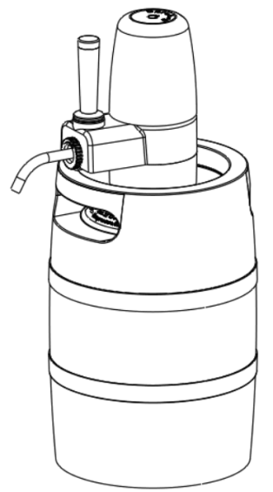
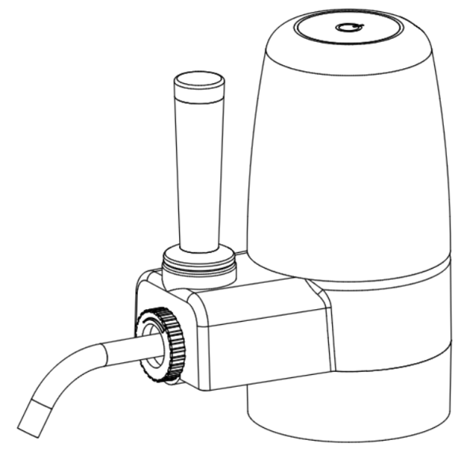

- Dimensions and Weight
  - Dimensions of portable dispensing tool:
The main dimensions requirements related to the fittings with other related products; exclude the detail dimension specification of components which is included in the components specifications.

Length of portable dispensing tool A: 169mm
Height of portable dispensing tool B: 136mm
Width of portable dispensing tool C: 72mm

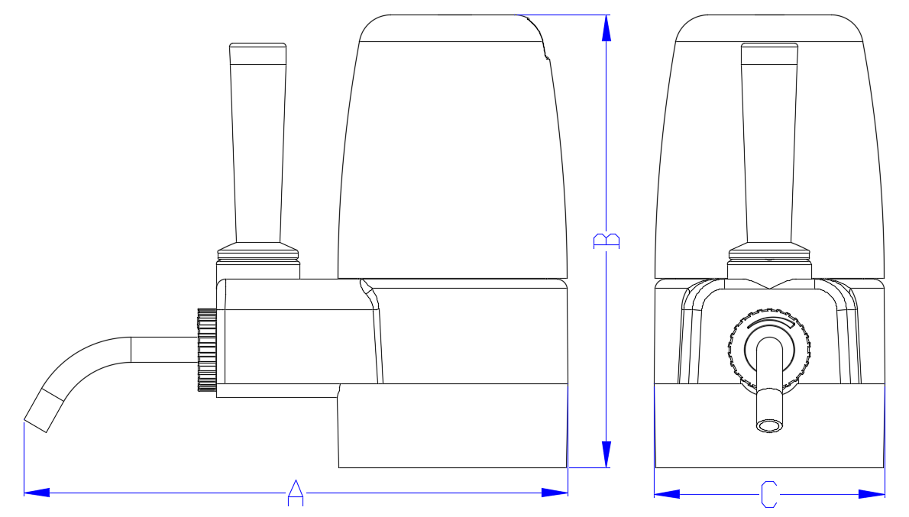

  - Weight of portable dispensing tool
Total weight with electrical pump: 0.28kg
Total weight without electrical pump: 0.20kg

- Pump and dispensing specification
  - pump specification
for the portable mini plastic kegs filled with carbonated beverages, e.g. the draft beer, at the beginning, pushed by the pressure from the carbonated beverages, even if without pressure medium, the beer and/or carbonated beverages will flow out when the beer valve opened; when the pressure from the beer and/or carbonated beverages dropped down, it will need pressure medium to squeeze the inner bag, to push out the beer and/or carbonated beverages inside the inner bag.
Base on this purpose, considering to completely empty the beer and/or beverages filled in the inner bag, or even to keep the carbonation of the beer and/or carbonated beverages, the specification of pump system:
- the minimum pressure of the compressed air from the pump system：0.5 bar.
- Minimum flow rate of electrical air pump：10L/min.

  - Dispensing specification
For draft beer and/or other carbonated beverages, especially for craft beer in draft, there will be always a lot of foam in glass during draft beer dispensing, the dispensing system need to be able to control the flow rate, and the foam level in glass for the draft beer dispeinsing:
Dispensing condition: beer temperature: 3°C; dispensing pressure: 1bar
Maximum draft beer dispensing speed: ≥1.5L/min
Foam level: 10mm ~ 30mm, 300ml glass
The foam level adjustment system can adjust/control the foam level in glass for different type of beer.

- Sealing performance specification
The portable dispensing tool connected on the spear of portable mini plastic keg, need to be sealed well with the spear head, to provide proper pressure for beer and/or beverages dispensing, even need to have enough pressure to squeeze the inner bag to completely empty the contents inside the inner bag :
  - normal environment condition (temperature 23℃±2℃，relative humidity 45%～55%）, 2 bar pressure inside the keg, no leakage between the portable dispensing tool and the spear head.
  - normal environment condition (temperature 23℃±2℃，relative humidity 45%～55%）, 2 bar pressure inside the keg, pushing down the elbow to open the beer valve, no air leakage between the keg and the inner bag.
  - normal environment condition (temperature 23℃±2℃，relative humidity 45%～55%）, 2 bar pressure inside the keg, pushing down the elbow to open the beer valve, no beer leakage from the elbow and/or dispensing tube.
  - normal environment condition (temperature 23℃±2℃，relative humidity 45%～55%）, 2 bar pressure inside the keg, pulling up the elbow to close the beer valve, no beer leakage from the elbow and/or dispensing tube

- DEFECTS：

  - General
    - The production, quality control and supplier should have processes in place to prevent defective product being supplied to customer; the aim being zero defects at delivery. An AQL value can only be applied for visual defects (attributes) and specific sampling purposes agreed upon. It is not an acceptable process average.
    - A lot that cannot guarantee a good product quality and/or a good performance on production lines, thus causing significantly more production stops than usual, will be refused for further investigation (The lot showing a significant difference from the standard deliveries).
    - If a lot is refused, the customer and Gpro Technology will co-operate in any quality investigation and economic study to minimize the impact on all parties. However, the supplier and relative department of Gpro Technology is ultimately responsible for resolving issues relating to defective deliveries and must gain the agreement of Gpro Technology for any action plan for resolution. If as a consequence, the lot is accepted, the supplier and relative departments remains responsible for any subsequent complaint or financial implication (including material / product losses, line stoppages, recall) relating to the original defect cause. See also point 10.2.
    - The supplier has a system in place that monitors internally the level of visual defects. The defects are put into categories (minor – major – critical) and reported on a weekly and/or monthly basis to calculate the process average for each category in the final supplied product per production line.
    - Visible defects other than mentioned will be classified by quality engineering/project engineering of Gpro Technology according to the definition given to each defect category.
    - The following example lists of defects within each category are not exhaustive and do not exempt the supplier and/or relative departments from responsibility regarding delivered goods (ref EC Council Directive 85/374 / EEC, Chapter 1).

  - Critical Defects absent ( 0ppm ).

- Critical defects will prevent product-ability or use under normal conditions of use, present a food safety / contamination or injury risk or will seriously mar the appearance of the product in the eyes of the customer / consumer.

- These defects should not be seen in random checks or in the entire lot.

Examples of critical defects:

1 | Pump leakage | A leakage in electrical and/or manual pump, can not provide or hold proper pressure inside the keg for dispensing | Any degree
2 | Block of tapping system | Blocks of handle, lever system, etc., the beer valve inside the spear can not be pushed open | Any degree.
3 | Missing part | A part of the assembly is missing | Any degree.
4 | Wrong Material | A part is made of another material than specified. Wrong colour. | Any degree.
5 | Severe Damage | One of the parts is damaged, for example cracked handle, deformed dispensing tube. | Any degree.
6 | Contamination | Any visible amount of grease, oil or foreign matter inside the dispensing tube, solvent odour. | Any degree.
7 | sealing issues | Dispensing tool can not seal well within specific pressure | Any degree.
9 | Wrong dimension | Dispensing tool can not connect with the spear head | Any degree.

  - Major Defects AQL 0.65% ( 6500ppm ) by attributes for visual defects

- Major defects will not mar the performance of the product.

Examples of major defects：

1 | Damaged pump housing | Scratched pump housing or base | Any degree
2 | Misaligned pump housing | Pump housing not aligned well with pump base | Any degree

  - Minor defects AQL 1.0 % ( 10000ppm ) by attributes for visual defects

- Minor defects will normally not be obvious to the customer / consumer.

Examples of minor defects
1 | Minor Scratching | Low grade marking of pump housing | Any degree
2 | Blooming (pump housing) | Flow marks on pump housing | Any degree
3 | Loss of texture (pump) | Scuffing etc from mould release | Any degree

- MODIFICATIONS

In general, any modification, demanding the technical specifications to be reviewed, should be approved.

  - The Supplier and relative departments should consult relative department of Gpro Technology at any planned modification of raw materials, specifications or packaging. These modifications should be communicated to relative department of Gpro Techonloty. Modifications cannot be made without notice or approval from Gpro Technoloty.
  - Depending on the nature of the modification, an appropriate test program should be run.

