- SCOPE:
  - This product specification document will constitute the basis of an important part of the design output based on the intention of the product and the product application.
  - As a general product specification, this specification include the general specification requirement and relative key technical requirement and standards of the portable mini plastic kegs, spear and inner bag assemblies, portable dispensing system; this specification document exclude the detail specification of specific components, which belongs to the detail control of internal process and/or incoming quality control, those specification please refer to the detail specification of components and/or components drawings.
  - Relevant international regulations related to product application and/or manufacturing, such as the relevant elements of ISO9000, and international regulations related to food contact, will form part of this product specification.

- DEFINITIONS AND ABBREVIATIONS
  - AQL : "Acceptable Quality Level", this is the maximum percentage of defect units in a lot, while the lot is still acceptable to the client. An AQL value should be considered for sampling purposes only and not as an acceptable process average
  - Lot : Quantity of goods, considered as a unity, for sampling purposes
  - Mil. St.: Military Standard
  - F.D.A.: Food and Drug Administration
  - ISO: International Standard Organization

- DOCUMENTS RELATED TO THE TECHNICAL SPECIFICATIONS
  - European Directives for Packaging materials(other countries/regions refer to the relevant directives, in principle, according to the strictest directives)
- Global Directive (materials and articles intent to contact with food) Regulation (EC) No 1935/2004
- Special directives (plastic materials and articles contact with food) Regulation (EU) No 10/2011
- Special directives (metal and alloy intent to contact with food) Resolution CM/Res (2013) 9
- Special directives (good manufacturing method …) Regulation (EC) No 2023/2006
- Special directives (food hygiene) Regulation (EC) No 852/2004

  - 85/374/EEC: Council Directive of 25 July 1985 on the approximation of the laws, regulations and administrative provisions of the Member States concerning liability for defective products。

  - Commission Directive 80/766/EEC of 8 July 1980 laying down the Community method of analysis for the official control of the vinyl chloride monomer level in materials and articles which are intended to come into contact with foodstuffs

  - Commission Directive 81/432/EEC of 29 April 1981 laying down the Community method of analysis for the official control of vinyl chloride released by materials and articles into foodstuffs

  - Federal Food, Drug and Cosmetic Act
- FDA CFR 21.175.300

  - ISO 2859 (Mil. St.-105D): Sampling procedures and tables for inspection by attributes。

- GENERAL CONDITIONS:
  - The portable PET plastic keg consists of the PET blow molded mini keg assembly, the spear/valves and beer inner bag assembly, and portable dispensing system.

  - The plastic keg assembly consists of the PET blow molded keg, PP injection molded handle, etc., which acts as a pressure vessel to locate and containing the bag and spear assembly, to contain beer and/or other carbonated beverages, etc.; with high strength and biaxial tension of PET resin in blow molding, the keg form a transportable pressure vessel, to stand the inner pressure from filled beer and/or carbonated drinks, and to prevent any possible explosion under high pressure.

  - The spear and inner bag assembly consists of spear housing, beer valve / gas valve, inner bag, dip tube, etc., the valves in the spear assembly control the gas (air, CO2, etc.), beer and/or beverages to go into and to go out of the keg; the beer/beverages are filled in the high barrier inner bag, pressure media goes into the space between the plastic keg and the inner bag, to push the beer/beverages out of the inner bag; as the pressure media not contact with beer, can use compressed air instead of CO2 for beer dispensing.

  - A 9 layers inner bag system applied in all portable PET plastic kegs; the inner bag are with extremely high barrier performance to both O2 and CO2, to provide extremely long shelf life for filled beer and/or beverages.

  - The spear and inner bag assembly control the compressed air, CO2 and beer in and out of the keg system, and the keg form a transportable pressure vessel, and therefore for safety purpose, it is essential that all dimensions related to the mounting and fixing of the spear in the keg, are well within the specified tolerances.

  - The keg assembly must in all respects be suitable to be filled with specified volume of beer and/or beverages at the specified pressure, the filled beer and/or beverages can be also completely emptied at the specified pressure.

  - The keg assembly complete with bag and spear assembly filled, and kept under normal circumstances will sustain foam (beer), appearance and taste of the beverage for about 12 months and there will be no leakage of contents or CO2 for at about 12 months.

  - The PET keg assembly and the spear/inner bag designed for one-way use.

  - The keg assembly complete with bag and spear assembly, filled draft beer in breweries will normally no pasteurization applied, in consequence, the spear and inner bag need to be sterilized:
- Preventive action: all components have to be produced under hygienic environment, and stored in closed sanitary container.
- Preventive action: any assembly process which with components contact with fingers, have to take preventive actions, to prevent any possible contamination of microorganism.
- If necessary, the final product need to take irradiation sterilization, or other sterilization, e.g. alcohol sterilization, high temperature sterilization, ozone sterilization, etc.

  - The portable dispensing tool consists of hand pump or electrical pump driven by rechargeable lithium battery, and dispensing system; the portable dispensing tool mounted on the spear of the portable mini plastic keg, to fill compressed air into the space between the mini keg and the inner beer bag by the hand pump or electrical pump, to squeeze the inner bag and push out the beer filled in the inner bag; the dispensing system open the beer valve by the lever system inside pushed by the handle, to pour the beer into glass; releasing or push the hand up, the beer valve in the spear will be closed automatically, to prevent the left beer in the dispensing tube and/or air goes in to contaminate the beer in the inner bag; the dispensing system include 2 foam control system, the foam level in the glass can be adjusted by one of the adjustable foam control system.

  - All materials and additives for spear and bag assembly have to comply with relative regulations of food safety, environmental health and safety, and other relative regulations (EU, and/or US relative regulations, e.g. FDA, etc.).

  - All components of the industrial packaging are reusable (returnable) or recyclable.

  - Product traceability: every box will be coded to indicate plant of origin, date of assembly, time of assembly. During assembly, the related batch code / production time of all parts will be correlated to the time of assembly.

  - The supplier respects the "First-In / First-Out" principle for all parts, during assembly, as well as for the delivery of the assembled keg assembly, resulting in each delivery to be as homogeneous as possible. The supplier is to practice stock rotation to maintain production chronology for deliveries.

  - The Gpro Technology may evaluate the quality system of the supplier and can have access to the manufacturing data.

  - If requested, the supplier is able to provide a quality assurance report for each production run according to the agreed format and including availability of individual measuring points.

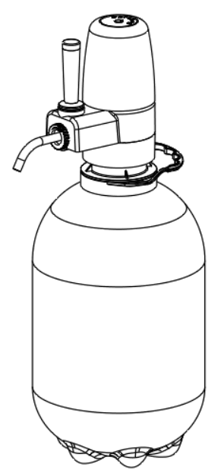
  - Before accepting a lot, Gpro Technology has the right to judge its conformity to the present specifications, using the sampling systems Mil. St. 105D and Mil. St. 414 (ISO 2859 & 3951).

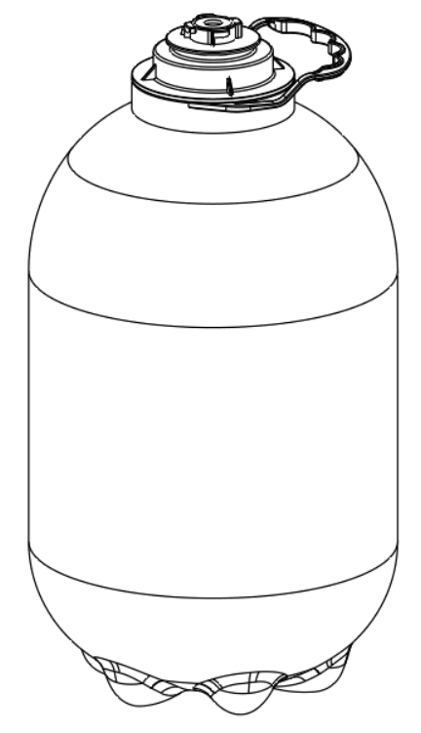

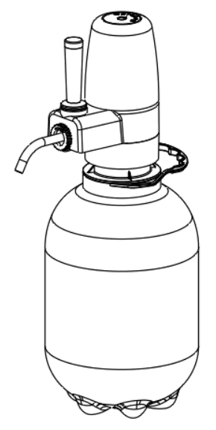

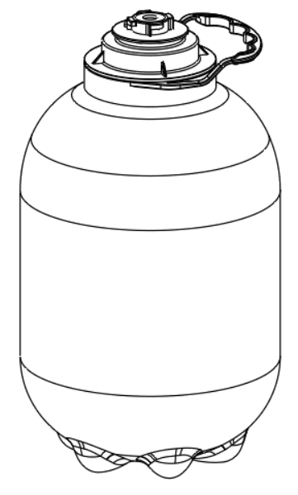

- Dimensions, Volume and Weight
  - Dimensions of portable mini plastic kegs:
The main dimensions requirements related to the product volume, strength, safety performance, and the fittings with other related products; exclude the detail dimension specification of components which is included in the components specifications.
    - External dimensions:
product  dimension | 5L PET keg | 3L PET keg
Outer Diameter A (mm) | 170 | 148
Height B (mm) | 320 | 263
Distance between bottom of keg and bottom of bottom chime C (mm) | 2.8 | 2.6

6 protruded parts on the bottom of the keg , a gap between the bottom of the keg and the bottom of the 6 protruded parts, to make the kegs stand stable on the flat surface even if pressure inside the kegs.
    - Wall thickness:
      - the minimum wall thickness for both 5L and 3L PET kegs: 0.6mm, to ensure the keg with enough strength to stand the inner pressure.
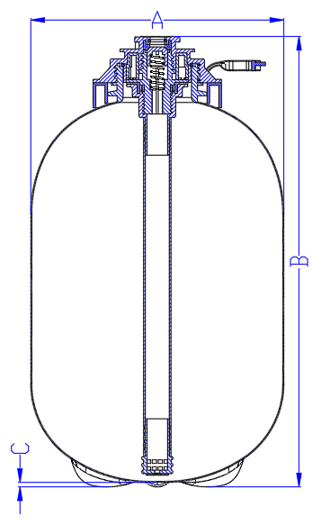

  - Volume of portable PET plastic kegs

product | 5L PET keg | 3L PET keg
Volume with spear/inner bag（L） | 5.2L | 3.2L

The complete keg with spear/inner bag, filled with specified volume of beer and/or carbonated beverages, there should be about 100ml head space in the keg, to contain the CO2 come out from the filled beer and/or carbonated beverages when temperature raise up or in transportation.

  - Weight of portable mini plastic kegs

product | 5L PET keg | 3L PET keg
Weight of empty keg with spear & bag （kg） | 0.32kg | 0.21

- Strength and safety specification
  - Keg strength and safety specification
When the plastic kegs filled with beer and/or carbonated beverages, in storage and/or transportation, with temperature increasing and transport situation (shaking, impacting, etc.), the CO2 will come out from the filled beer and/or carbonated beverages, and then create pressure inside the keg; for example, if CO2 content in the filled beer is 4g/L, when the temperature rise to 58°C (even higher temperature in container transported in summer time, or shipping near the equator), not considering the pressure change in plastic kegs with elastic deformation and/or plastic deformation under pressure, the pressure inside keg can rise to 6bar due to the CO2 comes out from the filled beer; the PET plastic keg should stand relative pressure without crack under relative environment condition; but as the PET plastic kegs are sensitive to stress concentration, to avoid any burst into piece of the PET plastic kegs under high pressure, it’s important not to put the PET keg filled with beer and/or carbonated beverages under high temperature.
Base on this purpose, considering abuse and/or other extreme condition, the relative strength and safety specification of portable PET plastic kegs:
- Tensile strength of overall portable PET keg：normal environment condition( temperature 23℃±2℃，relative humidity 45%～55%）, without any scratch mark on the PET keg, the keg can stand at least 8bar pressure without any crack.
- Safety strength of overall portable PET keg：normal environment condition( temperature 23℃±2℃，relative humidity 45%～55%）, even with scratch mark on the PET keg body, the portable PET kegs can stand at least 3bar pressure without any burst.
- Compression strength of keg neck: in beer and/or carbonated beverage filling process, the filling head press on the spear head to seal the keg for filling, under normal environment condition (temperature 23℃±2℃，relative humidity 45%～55%）, with 50kg static force on top of the spear head, no obvious deformation and broken will be allowed on the portable PET kegs, no any burst of portable PET kegs is allowed.
- Stacking strength：after plastic kegs filling, in storage and transportation, need to stack the plastic kegs for 7 layers or even 8 layers; in such condition, under normal environment condition (temperature 23℃±2℃，relative humidity 45%～55%）, with a 100kg static force on top of the portable PET kegs, within 12 hours, no obvious deformation and broken are allowed on the keg, no any burst of portable PET kegs is allowed.
- Handle strength：under normal environment condition (temperature 23℃±2℃，relative humidity 45%～55%）, a complete plastic keg full filled with liquid, hanging single handle for 1 hour, no any crack and/or broken on the handle is allowed.
- Strain strength：under normal environment condition (temperature 23℃±2℃，relative humidity 45%～55%）, with at least 8bar pressure inside the keg, no obvious deformation and crack/leakage on the plastic keg is allowed, the plastic keg can stand on flat surface stably.
- Safety temperature: as the portable PET keg is sensitive to stress concentration, it’s a risk when the kegs are pierced by nails, scratched by sand, etc. and then under high pressure, it’s important not to keep the PET kegs filled with beer and/or carbonated beverages under high temperature for long time in storage and/or transportation, to not create high pressure inside the portable PET kegs; the maximum temperature of the filled PET kegs: 35°C

  - Spear and plastic keg connection strength and safety specification
The plastic spear connected on the portable PET keg neck by threads, after beer and/or other carbonated beverages filling, when the pressure inside the keg rise to 6bar or more, according to the plastic keg opening design, there will be at least 75kg force on the spear, considering the safety, and abuse or other extreme condition:
- under normal environment condition (temperature 23℃±2℃，relative humidity 45%～55%）, with 6bar pressure inside the plastic keg, no shooting out of spear connected on the portable PET keg neck.
- under normal environment condition (temperature 23℃±2℃，relative humidity 45%～55%）, with 6bar pressure inside the plastic keg, no any crack on the plastic spear connected on the plastic keg neck.
- under normal environment condition (temperature 23℃±2℃，relative humidity 45%～55%）, with 6bar pressure inside the plastic keg, no any deformation and crack on the plastic keg neck, no shooting out of plastic spear connected on the plastic keg neck.

- Sealing and barrier performance specification
The portable PET kegs are mainly used to contain beer, as a beer container, according to the shelf life of beer, exclude the influence of microorganism:
- In whole shelf life, the oxyty of beer not exceed 1000ppb.
- In whole shelf life, the CO2 loss of beer not exceed 10%
According to 12 months shelf life of beer filled in portable PET kegs, the sealing and barrier performance specification for the portable PET kegs:
  - O2 and CO2 barrier performance specification
    - normal environment condition (temperature 23℃±2℃，relative humidity 45%～55%）, the overall O2 permeation within 12 months： ≤0.8ppm (800ppb)
    - normal environment condition (temperature 23℃±2℃，relative humidity 45%～55%）, the overall CO2 loss within 12 months : ≤10%
    - after inner bag folding, normal environment condition (temperature 23℃±2℃，relative humidity 45%～55%）, the O2 permeation rate of inner beer bag: ≤0.4ml/m².day.atm

  - Sealing performance of spear and inner bag
    - Inner beer bag：normal environment condition (temperature 23℃±2℃，relative humidity 45%～55%）, the plastic spear and inner bag mounted on the plastic keg neck，no any gas leakage on whole inner bag under 6bar pressure.
    - Plastic spear and plastic keg：normal environment condition (temperature 23℃±2℃，relative humidity 45%～55%）, the plastic spear and inner bag mounted on the plastic keg neck, no any gas leakage on the plastic spear and between the plastic keg and plastic spear under 6bar pressure.
    - Plastic spear and valves：normal environment condition (temperature 23℃±2℃，relative humidity 45%～55%）, the plastic spear mounted on the plastic keg neck, no any leakage on the valves (beer valve and gas valve) of plastic spear with 2 bar pressure from outside of the keg (-1bar vacuum inside the inner bag, or 2bar water pressure in spear/keg cleaning after filling).
    - Plastic spear and dispensing tool：normal environment condition (temperature 23℃±2℃，relative humidity 45%～55%）, the plastic spear mounted on the keg neck, dispensing tool mounted on the plastic spear, no any gas leakage between the plastic spear and the portable dispensing tool under 2bar pressure (filling pressure and/or beer dispensing pressure).

- Hygiene and microorganism
In general, no microorganism requirement regulations on the food packaging material, only strict microorganism regulations on the food itself; but for some of the food packaging, especially for draft beer packaging, after draft beer filling, normally no pasteurization applied for the filled kegs; if the microorganism in such draft beer is exceed the specification after filling, e.g. total numbers of colony, especially Bacterium acidi lactic, etc., will cause sour and smell of draft beer within 3~5 days under normal temperature; so, for the draft beer filling, besides strict microorganism requirements for the draft beer itself, also relative microorganism requirement for the packaging material; based on such requirement, considering no relative microorganism regulations for the packaging material, this specification will be only for the reusable plastic kegs internally:
- total numbers of colony for plastic spear and inner bag: 0; related to the actual control on hygiene and microorganism on production process, the plastic spear and inner bags need to be irradiation sterilized, irradiation dose: 15KGY
- total numbers of Bacillus coli in plastic spear and inner bag: 0；related to the actual control on hygiene and microorganism on production process, the plastic spear and inner bags need to be irradiation sterilized, irradiation dose: 15KGY

- Filling and Dispensing performance
The portabe PET kegs are mainly used for draft beer packaging, considering the foam influence during the draft beer filling and dispensing, under normal condition, the portable PET keg should meet the normal requirement of draft beer filling and dispensing.
  - Draft beer filling：
Filling method: filled upside up or upside down
Draft beer filling condition: beer temperature: 0°C ~ 3°C； filling pressure: 2.0bar， or with back pressure, pressure difference between filling pressure and back pressure: 0.5bar ~ 1.5bar
5L portable PET kegs: ≥5.0 liters
3L portable PET keg: ≥3.0 liters

  - Draft beer dispensing：
Dispensing method: specific portable dispensing tool
Dispensing condition: beer temperature: 3°C; dispensing pressure: 1bar
Draft beer dispensing speed: ≥1.5L/min
Foam level: 300ml glass, foam level: 10mm ~ 30mm
The foam level adjustment system can adjust/control the foam level in glass for different type of beer.
In draft beer dispensing, no CO2 on the top of the keg flowed out with the beer together, to influence the foam level in beer dispensing.

- DEFECTS：

  - General
    - The production, quality control and supplier should have processes in place to prevent defective product being supplied to customer; the aim being zero defects at delivery. An AQL value can only be applied for visual defects (attributes) and specific sampling purposes agreed upon. It is not an acceptable process average.
    - A lot that cannot guarantee a good product quality and/or a good performance on production lines, thus causing significantly more production stops than usual, will be refused for further investigation (The lot showing a significant difference from the standard deliveries).
    - If a lot is refused, the customer and Gpro Technology will co-operate in any quality investigation and economic study to minimize the impact on all parties. However, the supplier and relative department of Gpro Technology is ultimately responsible for resolving issues relating to defective deliveries and must gain the agreement of Gpro Technology for any action plan for resolution. If as a consequence, the lot is accepted, the supplier and relative departments remains responsible for any subsequent complaint or financial implication (including material / product losses, line stoppages, recall) relating to the original defect cause. See also point 10.2.
    - The supplier has a system in place that monitors internally the level of visual defects. The defects are put into categories (minor – major – critical) and reported on a weekly and/or monthly basis to calculate the process average for each category in the final supplied product per production line.
    - Visible defects other than mentioned will be classified by quality engineering/project engineering of Gpro Technology according to the definition given to each defect category.
    - The following example lists of defects within each category are not exhaustive and do not exempt the supplier and/or relative departments from responsibility regarding delivered goods (ref EC Council Directive 85/374 / EEC, Chapter 1).

  - Critical Defects absent ( 0ppm ).

- Critical defects will prevent machine-ability or use under normal conditions of use, present a food safety / contamination or injury risk or will seriously mar the appearance of the product in the eyes of the customer / consumer.

- These defects should not be seen in random checks or in the entire lot.

Examples of critical defects:
1 | De-Lamination  (handgrip) | A condition where the plastic separates into two or more layers due to inclusions, impurities, gas pockets etc. | Any degree
2 | Pin holes | Pin holes on inner beer bag | Any degree.
3 | Missing part | A part of the assembly is missing | Any degree.
4 | Wrong Material | A part is made of another material than specified. Wrong colour. | Any degree.
5 | Severe Damage | One of the parts is damaged, for example cracked chime, dent on keg | Any degree.
6 | Contamination | Any visible amount of grease, oil or foreign matter inside the spear.  Solvent odour | Any degree.
7 | Valve sealing issues | Valves can not seal well within specific pressure | Any degree.
9 | Wrong dimension of spear | Spear can not insert into or pull out of plastic kegs | Any degree.
10 | pallet | A certain degree insecticide or bactericide, etc. used on wooden pallet, volatilized material could contaminate the packed products at varying degree | Any degree.

  - Major Defects AQL 0.65% ( 6500ppm ) by attributes for visual defects

- Major defects will not mar the performance of the product.

Examples of major defects：
1 | Damaged chime/keg | Scratched chime or keg | Any degree
2 | Misaligned chimes | chimes not aligned with keg | Any degree

  - Minor defects AQL 1.0 % ( 10000ppm ) by attributes for visual defects

- Minor defects will normally not be obvious to the customer / consumer.

Examples of minor defects
1 | Minor Scratching | Low grade marking of keg or chimes | Any degree
2 | Blooming (keg/chimes) | Flow marks on keg/chimes | Any degree
3 | Loss of texture (keg/chimes) | Scuffing etc from mould release | Any degree

- MODIFICATIONS

In general, any modification, demanding the technical specifications to be reviewed, should be approved.

  - The Supplier and relative departments should consult relative department of Gpro Technology at any planned modification of raw materials, specifications or packaging. These modifications should be communicated to relative department of Gpro Techonloty. Modifications cannot be made without notice or approval from Gpro Technoloty.
  - Depending on the nature of the modification, an appropriate test program should be run.

