Spear bag （Pro & Eco）

- 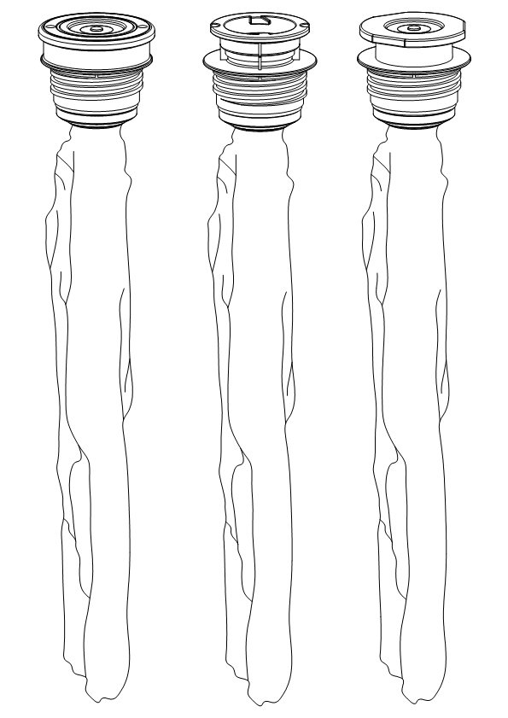Dimensions/Volume/Weight
 | 30L | 20L (pro) | 20L (Eco) | 18L (Pro) | 15L (Pro)
Diameter | 71.5 mm | 71.5mm | 71.5mm | 71.5mm | 71.5mm
Height | 530.0mm | 395.0mm | 560.0mm | 560.0mm | 475.0mm
Volume | 31.0 L | 21.0L | 20.5L | 19.0L | 16.0L
Weight | 0.24 kg | 0.21kg | 0.21kg | 0.21kg | 0.20kg
- Materials
Inner bag | 9 layers laminate, Multi layers high barrier
Valve | PA (food grade)
Spear housing | PA (food grade)
Springs (food contact) | Stainless Steel 304
Springs (non food contact) | Spring steel plated
Seals | TPE (food grade)
Others | HDPE
- Shelf life and barrier performance
Filled keg | Depends on filled beverage, up to 12 months
O₂ pick up per year | < 0.8 ppm
CO₂ loss per year | <10% (carbonization: 5.5g/L)
Sealing of spear/inner bag | ≥6 bar, free of leakage
Sealing of spear and keg | ≥6 bar, free of leakage
Sealing of valve from outside | ≥2 bar, free of leakage
Sealing of spear and metal coupler | ≥2 bar, free of leakage
- Mechanical/physical Properties
Operation temperature | 0°C ~ 45°C
Maximum dispense pressure | 3.5 bar
Strain strength (inside keg) | ≥10 bar, free of leakage of the keg body.
Connection strength (inside keg) | ≥10 bar, no shooting out and/or damage of spear head.
Opening pressure of safety valve | 8bar
Closing pressure of safety valve | 6bar
Maximum force loading on spear | ≥150 kg
Disposal | The Ecorekeg is designed to give an extreme low impact on the environment, the empty spear/bag is 100% recyclable, the product is 100% compliant to the EU Directive 94/62/EC
- Spear coupler type
S Type (EU Sankey) | D Type (US Sankey) | A Type (German Slider) | G Type (EU Sankey)

- Food contact and microorganism
Food contact approval | All materials and additives used for the components intent to contact with food comply with European regulation EU10/2011 and other regulations
FDA | All materials and additives used for the components intent to contact with food comply with FDA cfr 175.300
Flavor/taste stability | All materials intent to contact with beverages are free of small molecular migration and free of chemical reaction with content of beverages, keeping flavor/taste stability of beverages.
total numbers of colony for spear and inner bag | 0
total numbers of Bacillus coli in spear and inner bag | 0
DosAGe of irradiation | 10KGY
- Filling and Dispensing
Filling volume | ≥specified keg volume, beer temperature: 0°C ~ 3°C； filling pressure: 2.0bar
beer dispensing | No CO2 on top of inner bag comes out with beer together
- Packaging
 | 30L | 20L (Pro) | 20L (Eco) | 18L (Pro) | 15L (Pro)
Carton box size (mm) | 630x430x320 | 480x450x320 | 630x430x320 | 630x430x320 | 560x430x320
Spear bag per box (pcs) | 50pcs | 50pcs | 50pcs | 50pcs | 50pcs
Gross Weight (kg) | 13kg | 11.5kg | 11.5kg | 11.5kg | 11.0kg

