Portable dispensing tool for party keg

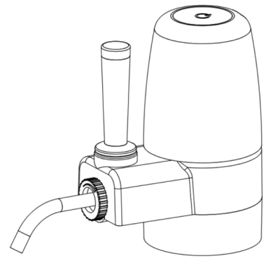
- Dimensions/Weight
Length | 169 mm
Width | 72mm
Height | 136mm
Weight (empty bag) | 0.28 kg
- Materials
Dispense Tube | HDPE
Pump housing | PC/ABS
Others | POM
- Mechanical/physical Properties
Operation temperature | 0°C ~ 45°C
Working pressure | 0.5bar(7.25psi) ~ 1.0 bar (14.5psi)
Battery | Lithium ion battery, 3.7V, 1100mAh
Maximum beer flow rate | ≥1.5L/min
Foam level | 10mm ~ 30mm (adjustable)
- Food contact
EU food contact approval | All materials and additives used for the components intent to contact with food comply with European regulation EU10/2011
FDA | All materials and additives used for the components intent to contact with food comply with FDA cfr 175.300
- Packaging
Box size  (mm) | Carton size  (mm) | Qty  (pcs) | Net Weight  (kg) | Gross Weight  (kg)
118 (L) x 75 (W) x 140 (H) | 480 (L) x 450 (W) x 310 (H) | 48 | 13.5 | 14.3

