5L mini
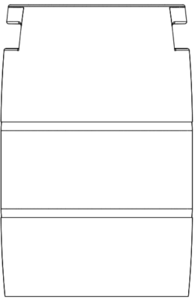
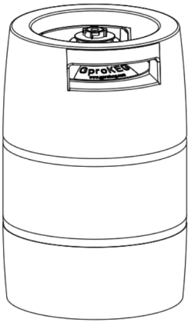
- Dimensions/Volume/Weight
Diameter | 200 mm
Height | 302mm
Volume | 5.2 L
Weight (empty keg) | 1.36 kg
- Materials
Inner bag | 9 layers laminate, Multi layers high barrier
Valve | PA (food grade)
Spear housing | PA (food grade)
Springs (food contact) | Stainless Steel 304
Springs (non food contact) | Stainless Steel 304
Seals | TPE (food grade)
Keg | HDPE, glass fiber, epoxy
Others | PP
- Shelf life and barrier performance
Filled keg | Depends on filled beverage, up to 12 months
O₂ pick up per year | < 0.8 ppm
CO₂ loss per year | <10% (carbonization: 5.5g/L)
Sealing of spear/inner bag | ≥6 bar, free of leakage
Sealing of spear and keg | ≥6 bar, free of leakage
Sealing of valve from outside | ≥2 bar, free of leakage
Sealing of spear and metal coupler | ≥2 bar, free of leakage
- Mechanical/physical Properties
Operation temperature | 0°C ~ 45°C
Maximum dispense pressure | 2 bar
Strength at break | ≥8 bar, free of burst into pieces
Piercing/stress strength | ≥6 bar, free of burst into pieces by piercing keg and/or with scratch mark
Impact strength | ≥6 bar, free of burst into pieces by dropping from 2m height.
Handle strength | ≥1 hour, no crack on handle of keg full filled.
Strain strength | ≥8 bar, free of leakage of the keg body.
Connection strength | ≥6 bar, no shooting out and/or damage of spear head.
Maximum force loading on spear | ≥100 kg
Disposal | The Gprokeg is designed to give an extreme low impact on the environment, the empty keg is 100% recyclable, the product is 100% compliant to the EU Directive 94/62/EC

- keg coupler type
Specific coupler fit with Gprokeg specific dispensing/filling tool
- Food contact and microorganism
Food contact approval | All materials and additives used for the components intent to contact with food comply with European regulation EU10/2011 and other regulations
FDA | All materials and additives used for the components intent to contact with food comply with FDA cfr 175.300
Flavor/taste stability | All materials intent to contact with beverages are free of small molecular migration and free of chemical reaction with content of beverages, keeping flavor/taste stability of beverages.
total numbers of colony for spear and inner bag | 0
total numbers of Bacillus coli in spear and inner bag | 0
- Filling and Dispensing
Filling volume | ≥5.0 liters, beer temperature: 0°C ~ 3°C； filling pressure: 2.0bar
beer dispensing | Foam height: 10mm~30mm, beer temperature: 3°C; dispensing pressure: 1bar
- Palletizing
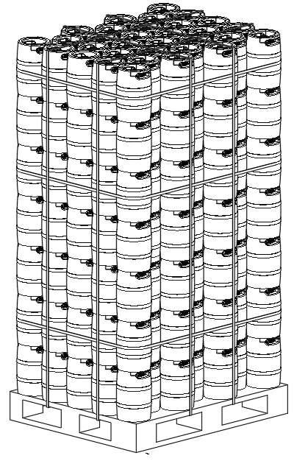
Empty keg
Pallet size | 1200x1000x110mm, one-way
No. of layers | 8
Kegs per layer | 32
Kegs per pallet | 256
Orientation | Upside up
Height | 2.46m
Weight | 337kg
Pallets are wrapped with stretch film

Filled keg
No. of layers | 8
Kegs per layer | 32
Kegs per pallet | 256
Orientation | Upside up
Height | 2.46m
Max. layers in warehouse | 16

